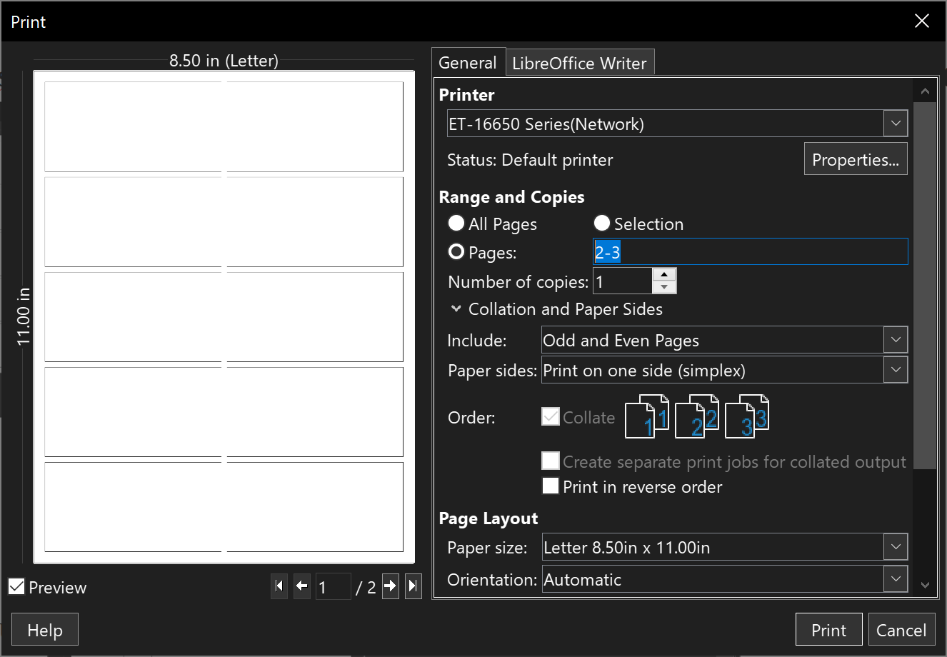
Step 1) When you print these flashcards, make sure to select pages, and enter in only the pages you want to print, as shown below.

Step 2) Then make sure to print on both sides, flipping on the long edge
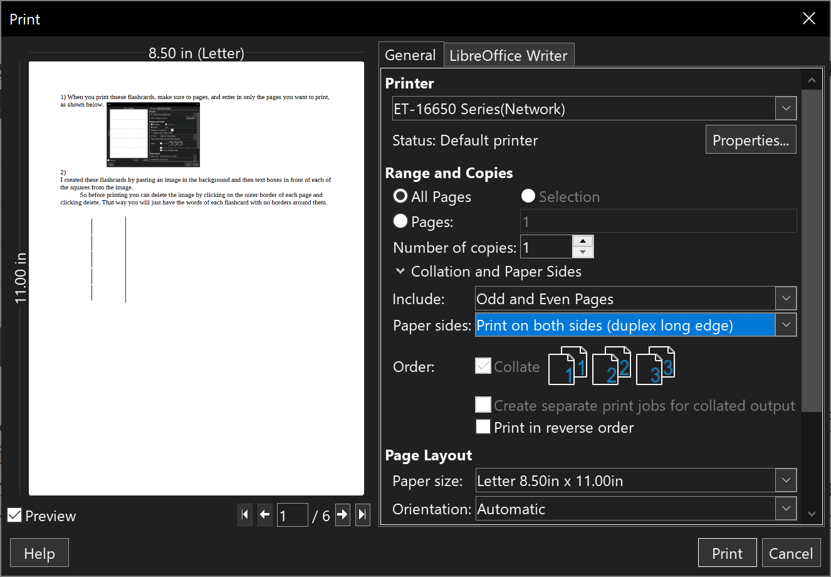

Creating your own Flash Cards:
I left some blank pages so you can make your own flash cards. Page 1 is the front side and page 2 is the backside of page 1.
When you typen in your answers on page two, you have to put your answeres on the oposite side of the page, to the coralating qestion, for it to print right. See below

Page 1 Question (front of flashcard) Page 2 Answer (back of flashcard)

A1
A2
A4
A3
A6
A5
A8
A7
A10
A9
Q1
Q2
Q3
Q4
Q5
Q6
Q7
Q8
Q9
Q10

How I created this:
I created these flashcards by pasting an image in the background and then text boxes in front of each of the squares from the image.

Note: The Colored *** Just mean I use the same truth on a different flash card somewhere.


I can fight sin/die to myself tomorrow.
- I’ve already sinned, so more sinning won’t make a difference.

- I’m not perfect anyways, so it doesn’t matter that much if I sin a little more.
God will just forgive me again, so this sin won’t affect me.
God won’t reward me until way later.
God won’t punish me until way later.
I’m already so far under God’s discipline, that sin is the only short term pleasure I can expect.
- Nobody will see or know what I did.
- There will be rewards or punishments for what I do, but it won’t effect my relationship with God.
- My mind is so hard to control, that I give up trying to control my thoughts.

- I get so attacked every time I do God’s will that perfection of thoughts isn’t even possible.
-I’m to easily triggered.

- Once I’m triggered, it’s too hard to stop.
- Against you alone have I sinned. (Psalm 51:4)
- Without holiness no one will see the Lord.
(Hebrews 12:14)
- God is with us when we seek good, but against us when
we seek evil. (2 Chronicles 15:2/James 4:8)
* Die to myself daily. (1 Corinthians 15:31)
- God says put on the breastplate of righteousness today. (Ephesians 6:14)
* If I deliberately keep on sinning no hope for repentance is left. (Hebrews 10:26)
* If I confess my sins, I can be cleansed of righteousness and be free from sin today. (1 John 1:9)
* Continuing in sin hardens my heart, making things worse. (Hebrews 3:8,15)
* If I continue to do the things of the flesh, it will be harder to do the things of the Spirit. (Galatians 5:17)
* I will reap what I sow. (Galatians 6:7)
- Today is the day God wants me to change. (2 Corinthians 6:2)
* Continuing in sin hardens my heart, making things worse. (Hebrews 3:8,15)
* Die to myself daily. (1 Corinthians 15:31)
- If I don’t discipline myself today, I am starting on a path that can make me a castaway. (1 Corinthians 9:27)
* If I confess my sins, I can be cleansed of righteousness and be free from sin today. (1 John 1:9)
* If I deliberately keep on sinning no hope for repentance is left. (Hebrews 10:26)
* If I continue to do the things of the flesh, it will be harder to do the things of the Spirit. (Galatians 5:17)
* I will reap what I sow. (Galatians 6:7)
* God is a good father, and won’t delay to long. (Ephesians 6:4)
- He rewards those who earnestly seek him. (Hebrews 11:6)
- If I draw near to God he will draw near to you. (James 4:8)
- He will be my very reward. (Genesis 15:1)
- God rewards on earth. (Proverbs 11:31)
- Every good and perfect gift comes down from the father of heavenly lights. (James 1:17)
- If he did not withhold his son, he will not withhold any good thing, in a good time. (Romans 8:32)
- Even Jesus endured his hardest trial expecting a reward afterwards. (Hebrews 12:2)
- He disciplines those he loves. (Hebrews 12:6)
- His anger does flare up, and lasts for a while.
(Psalm 30:5/Psalm 30:5)
- The bible says his discipline is similar to earthly fathers,
so it will be timely. (Hebrews 12:10)
- He knows we operate in short term, compared to him, and his discipline accounts for that.
(Isaiah 57:16/Psalm 78:38-39)
- God does not exasperate his children, because he is a
good father (Ephesians 6:4)
* His anger lasts a short time, and his mercies are new
every morning.
(Isaiah 57:16/Psalm 78:38-39/Lamentations 3:22-23)
* If I continue to do the things of the flesh, it will be harder to do the things of the Spirit. (Galatians 5:17)
- God’s discipline is according to the severity of the sin. (Hebrews 12:10)
* Continuing in sin hardens my heart, making things worse. (Hebrews 3:8,15)
- We can loose the good things God has for us by not doing his will. (Galatians 6:9)
* If I continue to do the things of the flesh, it will be harder to do the things of the Spirit. (Galatians 5:17)
* I will reap what I sow. (Galatians 6:7)
- God created me to be triggered by things, so I can just as
quickly be triggered to turn off the hormones and
feelings. (1 Corinthians 10:13/Psalm 139:14)
* I can do all things through him who strengthens me.
(Philippians 4:13)
- If we don’t try to control our thoughts, God said they will
destroy us. (James 1:15)
- The heart is the wellspring of our soul, we need to guard it
above all else. (Proverbs 4:23)
* I can do all things through him who strengthens me.
(Philippians 4:13)
- Be transformed by the renewing of your mind. (Romans 12:2)
- Whatever is pure, noble praiseworthy, think about such
things. (Philippians 4:8)
- Jesus wants me to be sanctified, and pure. (1 Thessalonians 4:3)
- Sinful thoughts are the same as actually sinning to God.
(Matthew 5:21-22, 27-28)
- Good and evil deeds cannot be hidden, because God brings both to light on earth. (1 Timothy 5:25/Luke 6:45)
Text
Text
Text
Text
Text
Text
Text
Text
Text
Text
Text
Text
Text
Text
Text
Text
Text
Text
Text
Text

