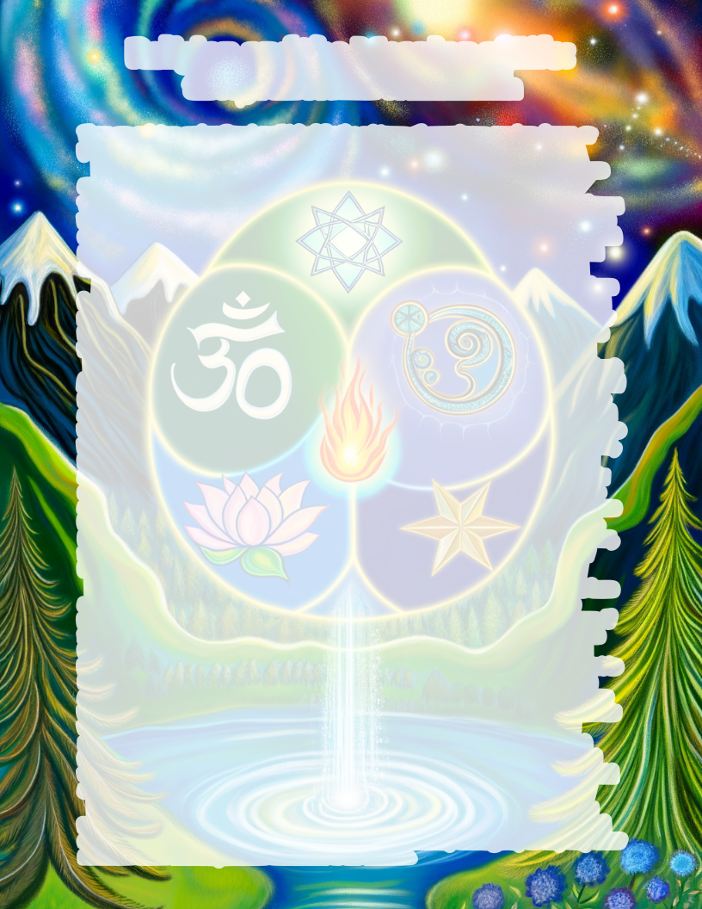
Religion and the Meaning of Life:
through the Process of Elimination

There are only two explanations I can think of, for the existence of our universe, random chance, or purposeful creation.
First I want to explore the possibility that random events lead to the existence of our universe and to earths complex ecosystem.
The Laws of Thermodynamics say that energy cannot be created, and all physical things are going from a more organized state to a less organized state. For example the sun is cooling down, the rotation of the earth is slowing, the universe is expanding, and all usable energy is slowly decreasing. Logic tells us that our universe had a beginning, but it seems chance is an unlikely explanation for the organization and diversity of our universe and earths ecosystem.
To make random chance more unlikely, all the matter and energy from our universe would have had to be stored for an infinite period of time, and only recently developed into our current organized state. As of now, I couldn’t find any form of stored (potential) energy that doesn’t slowly decrease over time, similar to a battery. So all the energy needed to randomly create our universe, would likely have run out ages ago.
To make chance even more unlikely, say that all the elements and energy for life did come about by chance, and some kind of plant cell was formed with all the DNA necessary to reproduce itself, and all the elements of sunlight, CO2, water, minerals and nutrients were present in just the right amounts to support its existence. The harsh environment of earth would make it unlikely for this cell to survive and multiply very long. Either something would get to hot, or an injury or mutation would hinder its ability to perform some fundamental of life, etc. And even if the cell did multiply and survive for millions of years, they would likely be similar to parasites destroying everything in their path, until they run out of sustainable energy and die. Not transition into new species and adapt. There are millions of species in our current ecosystem, but scientists struggle to find evidence for even one species transitioning into another in the last 1,000 years. On the other hand scientists have documented over one thousand three hundred species that have gone extinct over the last 1,000 years. For these reasons, and many more, (such as the relatively short time our universe can sustain life, the unlikelihood of trillion cell organisms, the complexity of consciousness and thought etc.) it is worth considering if there was some kind of intelligent being involved in the creation of our diverse ecosystem and universe.
There are an estimated 4,000 religions in existence today, but most of them are unlikely to have a reliable account about the beginning of our universe. I’m not interested in impossible to prove philosophies and theories, about what some random person thinks happened to create our universe. If there was someone involved in the existence of our current universe and earths ecosystem. I can see from his creation, that he would have power, wisdom, understanding and a form of order. If such a person existed or still exists, I would expect him to have a purpose for why he went through the effort to create things; and I would expect him to share his purpose soon after he finished creating it. Not sit around for thousands of years after finishing the universe, before suddenly having an urge to tell some random person everything he did and why. I would expect the sacred text of such a creator to reflect his wisdom, knowledge, order and power. It should not be vague, unorganized, simplistic or full of contradictions, but well thought out, concise and orderly. I would expect the creator to go to great lengths to preserve and verify the account (sacred text) of what he made. If the creator is still alive, I would expect him to interact with his creation, in whatever ways his sacred text claims he does. I would also expect the religion to still be active, if it claims to have a living creator, as almost all do.
For lack of time to explore what every spiritual guru claims is true, I will only be considering religions that meet most or all of what I would expect from someone who could create a universe and earths ecosystem. I will briefly describe the closest matches I could find, focusing only on why they did or did not fit what I would expect from the creator of our universe.
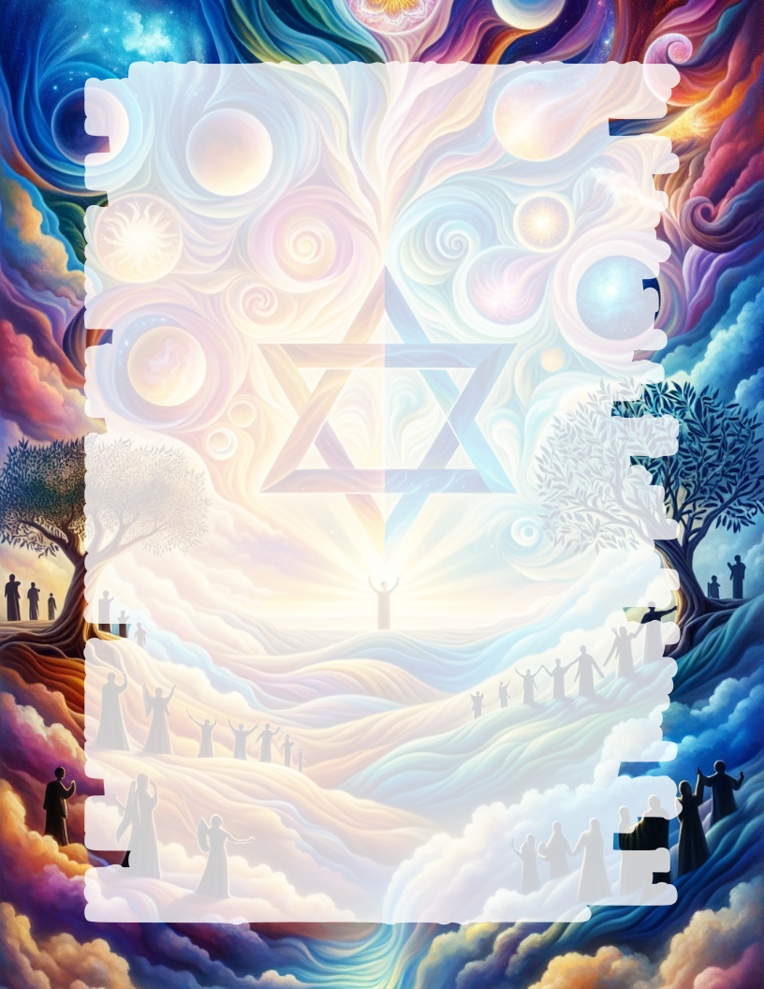
Hinduism has so many Gods and sacred texts that it doesn’t seem orderly. There may be themes, but I don’t see a clear unified message, as I would expect the creator of our universe to have. There are many contradictory sacred texts, and I don’t see enough physical evidence to show that their Gods are actually doing what they claim.
Zoroastrianism claims their revelation was given to Zoroaster (1500 BCE) long after the creation account. The first non-oral written accounts were created 400 CE – 1900 CE. Zoroastrianism seems to be heavily influenced by Judaism and Christianity, which pre-date it.
Islam claims to be an addition to the Jewish/Christian sacred texts. But Islam deviates from the Jewish and Christian sacred texts in many ways. For example, instead of focusing on God’s sacrifice to forgive sins, the Qur’an emphasizes a works based way to earn God’s forgiveness. Another way Islam differs is claiming that Ishmael was the son of promise not Isaac. This may seem small, but according to the Jewish sacred texts, Isaac is the chosen son, and from his descendants comes the messiah. This is also what the Christian sacred texts say. So a religion emphasizing Ishmael’s descendants as God’s chosen people thousands of years later doesn’t fit the narrative from the Jewish and Christian sacred texts, which Islam claims to be part of.
Taoism / Daoism claims to be revealed to a man around 600 BCE, long after the creation of the universe. It’s kind of a philosophy or unprovable theory, about the universe having some form of consciousness, and being able to perpetually recreate itself, among other things. It claims it cannot be fully explained in words. Taoism seems to delight in confusion rather than logic and order, and the ambiguous vague nature of it’s sacred texts makes it hard to verify any of its claims.
Judaism has an ancient sacred text, (first 39 of the 66 books in the Bible) which claims to go back to the creation of the universe. It immediately begins describing the purpose of why we were created, in a logical organized manner. Stating how God wanted to interact with his creation and display his characteristics of kindness, humility, justice, power, forgiveness etc. Their creator is described as all-knowing, wise, powerful, and orderly, like our universe reflects. Within the sacred text there are many verifying physical proofs. Including detailed foretellings of what Jesus (the messiah) would do before it happened; and copies have been found, written before the events took place (including Isaiah 53). There were also massive world wide miracles like the flood, or the Israelites escape from Egypt that can be examined in geology and archaeology. And their God claims to still be alive. There are many things he says in their sacred text, that we can test and see if he does. He says seek me with all your heart and you will find me.(Deuteronomy 4:29) He claims to answer all prayers that are not offensive to him. (Isaiah 65:24/Psalm 65:2) And he says when we tell him what we are worried about, he will help us.(Psalm 55:22)
Christianity is a continuation of the Jewish sacred texts (all 66 books of the Bible), it explains that Jesus is the messiah, who is God in the form of man. It explains that all the sacrifices were a picture of how Jesus would willingly die, to pay for our sins, delivering us from the wrath of God. Christians believe that over 300 prophecies in the Jewish sacred texts are speaking about Jesus; including Isaiah 53, which predicts in detail, Jesus death and resurrection to take away sins. The Bible explains that everyone who believes that Jesus died for their sins, and turns from their sins to follow Jesus, will receive eternal life when they die. The Christian Bible claims to be the final complete revelation from God, starting at the creation of the Universe, and predicting God’s final destruction of the world and his re-creation of a new everlasting world.
There are many religions that claim to be additions to Judaism and Christianity. Stating that faith and sacrifice are not enough to forgive sins, (most notably, Muslims, Mormons and Jehovah’s Witnesses). But their sacred texts came after Judaism and Christianity, so wherever they disagree shows their unreliability and untrustworthiness, to the unified Judeo-Christian message.
In conclusion, I believe that random chance is an unbelievable explanation for the universe and earths ecosystem, and an intelligent creator is an option that should be considered. Based on what I would expect a creator to be like, and my own interactions with the person described in the sacred texts of Judaism and Christianity. I believe there is a creator, and our purpose is to live for him.

