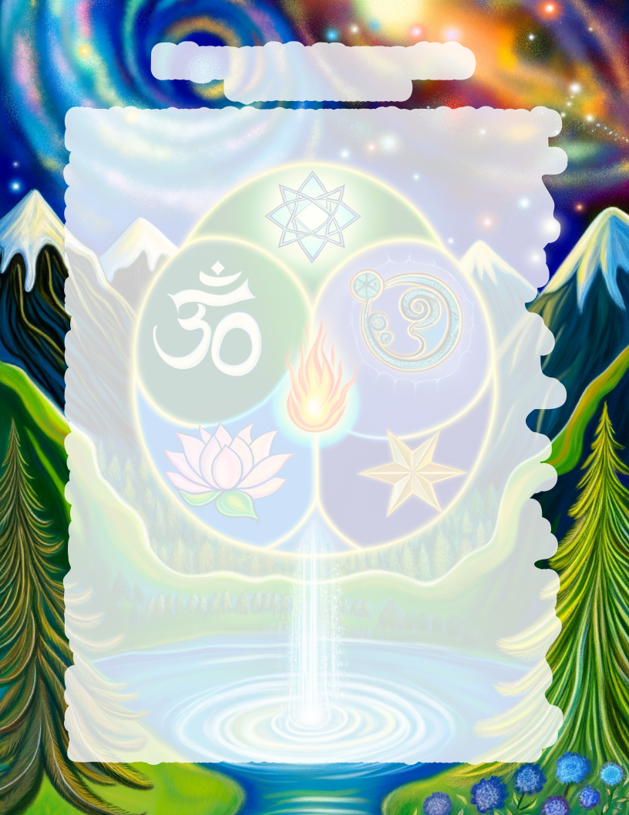
Religion and the Meaning of Life:
By Process of Elimination

Ultimately there are two options for the existence of our universe: It has come about by chance, or it has been created by an intelligent designer (religion).
First, let us look at the possibility that random events have brought about the universe and the planet we call home. Consider the power, complexity, and fragility of our universe.
Our Solar System is powered by a 92% hydrogen fireball. Our little speck of a planet could fit 13 quadrillion times into the largest known star. The Earth sits 93 million miles away from our radioactive emitting ball of plasma protecting itself with a magnetic field. It generates this shield with a molten iron and nickel core generating electric current. Our earth spins at an ever-slowing rate of 1,038 miles per hour. We are orbited by a moon that is drifting away from us yet still provides vital tides and stabilizes the tilt of the earth, creating seasons. Our earth and moon orbit the sun at 67,000 miles per hour. Our Solar System orbits the Milky Way galaxy at 514,000 miles per hour. The Milky Way galaxy travels at 1,340,000 miles per hour.
The scientific laws of Thermodynamics say that energy cannot be created, and all physical things are going from a more organized state to a less organized state. To put it simply, our universe is dying from heat death. Ever so slowly, life sustaining energy is decaying.
On a more relatable level, the earths finely tuned ecosystems are slowly crumbling and falling out of balance. The genetic code of the human race is becoming increasingly corrupt, leading to mutations such as cancer, arthritis, Parkinson’s etc. In the last 100 years, it's estimated that up to 500 species of vertebrates have gone extinct. The human population grows at an unsustainable rate.
We must inevitably conclude that instead of order and growth, chance and time brings disorder and a loss of life and energy. You may come to your own conclusions, but I believe the incomprehensible complexity of life, both under the microscope and the telescope require us to examine the possibility of a creator.
There are an estimated 4,000 religions in existence today. If one is true, it must match our observed reality in every way. All could be wrong, but only one could be right. It is apparent from earth’s design that if there is a creator, he would have incredible power and knowledge. This entity must be eternal, or it would have ceased to exist in infinity past.
If such a creator existed or still exists it would be logical to expect him to have a purpose for creating our universe. I would expect a creator to communicate with his creation. Most religions have a written text that is believed to be the revelation of their “creator God.” We must expect the writing of this powerful being to reflect his nature both in accuracy, knowledge and rational appearance. We must expect clarity, consistency, and order. Surely a creator would go to great lengths to preserve his sacred text. If the creator is still alive, I would expect him to interact with his creation.
For lack of time to explore what every spiritual guru claims, we will consider the most popular religions on earth, focusing on whether or not they could be a logical answer to our existence?
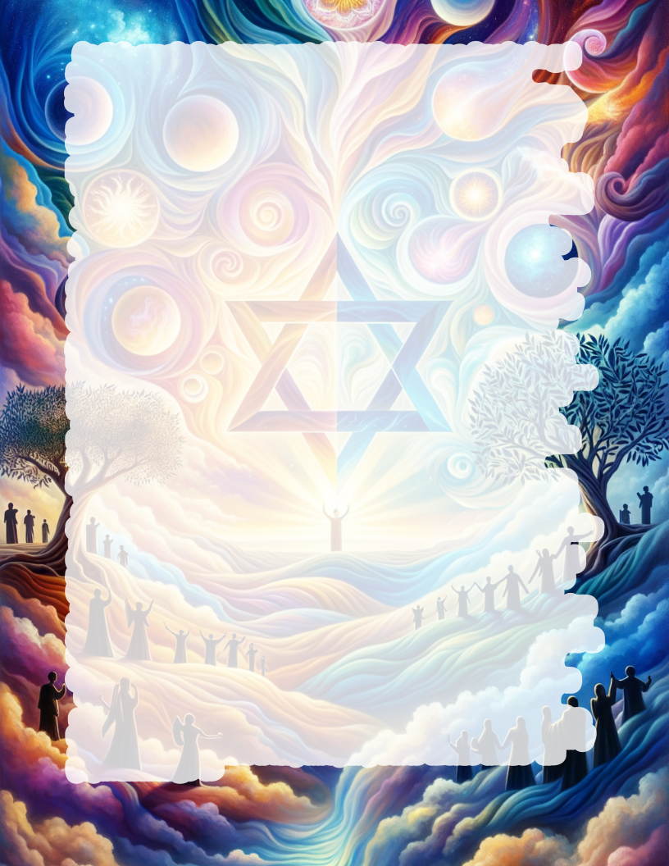
Hinduism (1.1Billion) is by some considered the oldest living religion, has so many gods and sacred texts that it lacks order and consistency. There may be themes, but it doesn’t have the clear unified message that would be expected from a creator of our universe. Hindus have many contradictory sacred texts. Their God’s claim to be able to help in all aspects of life, but there is no great evidence that their gods are doing what they claim.
Taoism / Daoism (20 million) claims to be from a revelation given around 600 BCE (long after the creation of the universe). It’s a philosophy which believes the universe has some form of consciousness and being, making it able to perpetually recreate itself. It claims that it cannot be fully explained in words. Taoism seems to emphasize mystery and confusion rather than logic and order.
Zoroastrianism (100-200 thousand) is favored by some because of how old it is. It claims Zoroaster received his revelation around 1500 BCE; long after creation. The first written (non-oral) accounts were created 400 CE – 1900CE. This bodes poorly for the accuracy since oral tradition tends to drift. It seems to have significant influences from Judeo-Christian religion, which predates it.
Islam (1.8 billion) claims its sacred text is a new revelation to the Jewish/Christian sacred texts. But Islam’s Qur'an deviates in doctrine from the original Jewish/Christian sacred texts, making it incompatible. The Qur'an emphasizes a works-based method to earn God’s favor. The Christian/Jewish Old Testament says that faith and God’s sacrifice for sin is the only way to find favor with God. Islam follows a different people group (Ishmael’s descendants instead of Issac’s) who claim to be chosen by God. Again this is inconsistent with the Biblical story line, which the Qur’an claims to be a part of.
Judaism (14 million) follows an ancient text called the Old Testament (First 39 of the 66 books in the Bible). The Jewish text describes the purpose of all creation in a logical organized manner. It explains God’s desire to interact with His creation and display His character. It explains that He is separate from us because of our sin. The creator is described as all-knowing, wise, powerful, and orderly, just like our universe demonstrates. Within the sacred text there are many physical proofs including: internal consistency, historical accuracy, and detailed foretelling of the future. There were also worldwide miracles like Noah’s flood, or the Israelites escape from Egypt which can be examined in geology and archaeology. The Jews are still waiting for the savior, predicted by the Old Testament.
Christianity (2.2 billion) includes the New Testament, which is the continuation of the Old Testament (Jewish sacred text). Christianity claims to be without any contradiction to the Jewish text of the Old Testament. Christians believe that over 300 messianic prophecies of the Old testament are speaking about Jesus (the God man); including texts such as Isaiah 53. The New Testament (last 27 of the 66 books in the Bible) expands and explains the Old Testament. It shows that Jesus was the only possible fulfillment to the prophecies (he is the promised messiah Judaism still awaits). Jesus claims to be God, and to have died a sacrificial death, in order to pay for the sins of the world, so that he could save us from the wrath of God. Jesus requires his followers to repent from sin and believe what has been revealed in the Bible. The Jews who accept Jesus as the messiah are known as Messianic Jews (Christians with a Jewish lineage). The Christian Bible claims to be the final complete revelation from God, starting at the creation of the Universe, and predicting God’s final destruction of the world and his recreation of a new everlasting world.
Christianity has many spin offs including Muslims, Mormons and Jehovah’s Witnesses. These religions claim to be a continuation of the Bible but stand in stark contrast to many of the Bible’s teachings.
In conclusion, I believe that random chance is an inadequate attempt to explain life on earth. Based on my observations of the most ancient, trustworthy and logical religions, I have no doubt that Christianity is the only explanation consistent with reality. Consequently, to live for the God of the Bible is the purpose and meaning of life.

